## How to burn firmware for mycobot280 and mycobot320

**1. First of all, it should be clear that mycobot280 is divided into mycobot280-M5 version and mycobot280-Pi version. Similarly, mycobot320 is also divided into mycobot320-M5 version and mycobot320-Pi version. Before burning the firmware, please confirm your robot model.**

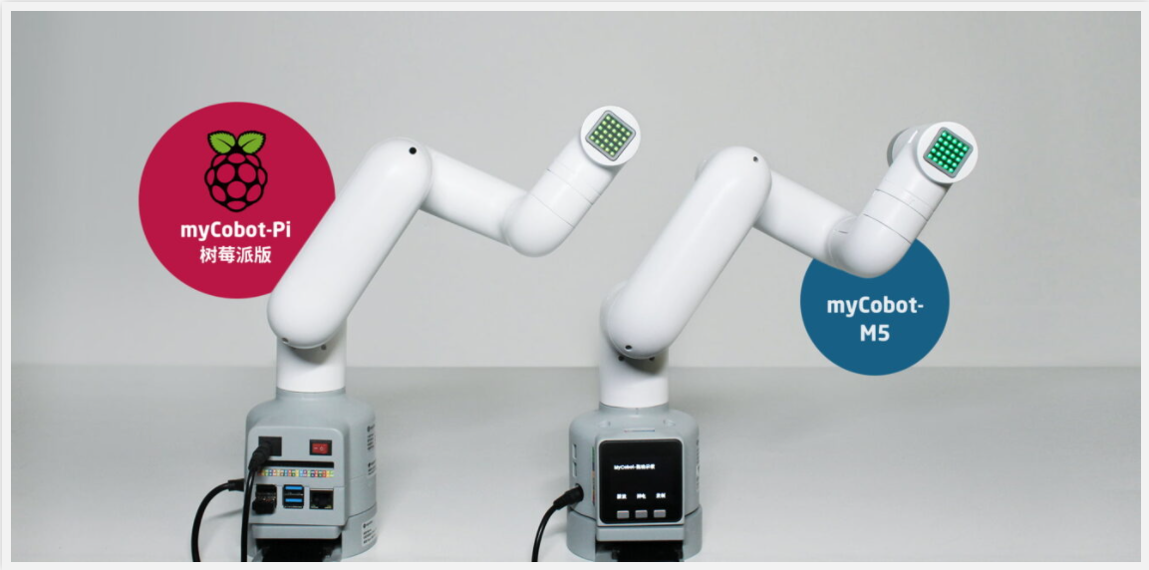

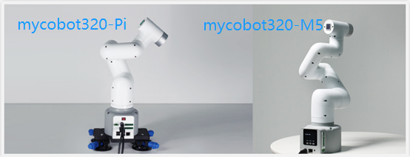

**2.The programming methods of mycobot280-M5 and mycobot320-M5 are the same, and they will be explained together.**

1. Install the basic driver.

（1）Connect the USB to typeC cable to the laptop and the mycobot280-M5 or mycobot320-M5 robotic arm basic. View the serial port model in the device manager (there are two types of serial ports that can be viewed at present, as shown in Figure 1 and Figure 2).

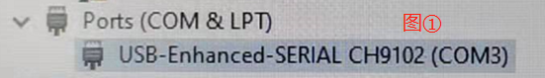

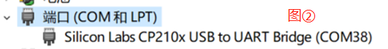

（2）If the serial port found is shown in the figure, please download the basic driver shown in the figure below from <https://docs.m5stack.com/en/download>

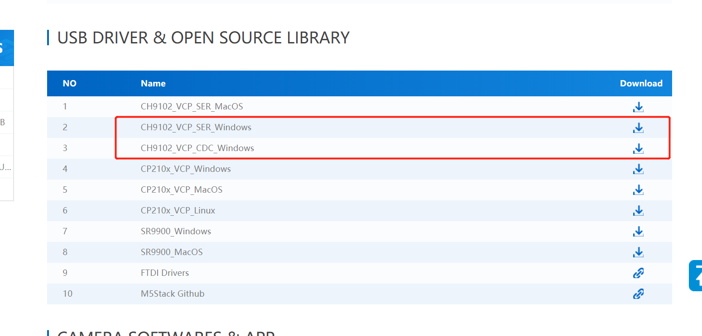If the serial port found is as shown in the figure, please download the basic driver corresponding to the computer system in the link below.

Windows10:https://www.elephantrobotics.com/software/drivers/CP210x_VCP_Windows.zipMacOS: https://www.elephantrobotics.com/software/drivers/CP210x_VCP_MacOS.zipLinux: https://www.elephantrobotics.com/software/drivers/CP210x_VCP_Linux.zip

1. Install the atom driver.

Please download the atom driver at this link.

Windows10: <https://www.elephantrobotics.com/software/drivers/CDM21228_Setup.zip>

1. Download mystudio burner.

Download mystudio software at this link.

https://www.elephantrobotics.com/download/

1. Open the mystudio software.

（1）Burn basic firmware. Connect the USB to typeC cable to the laptop and the mycobot280-M5 or mycobot320-M5 robotic arm basic. As shown in the figure below, select the corresponding device (a blue box indicates successful selection), port, language and region, and click login.

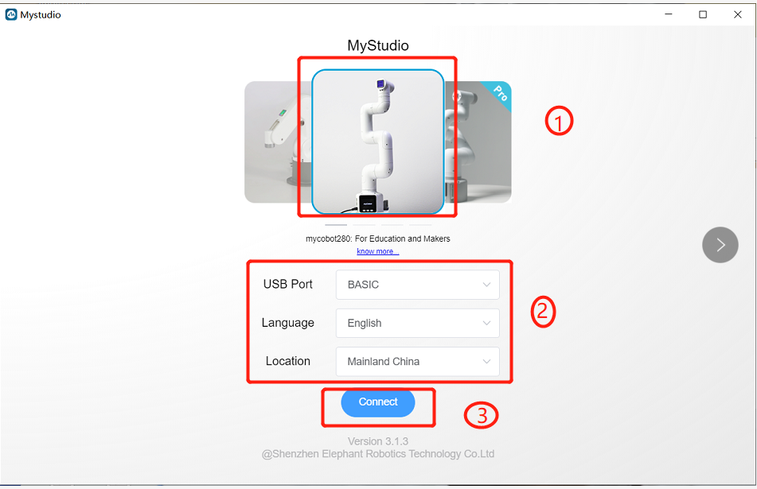

After entering, select the minirobot1.0 firmware, click to download, and then burn it (the percentage will increase during the burning process, and the final display of 100% means that the burning is successful).

（2）Burn the atom firmware. Unplug the typeC end from the basic arm and insert it into the top atom.

Then the following figure indicates to burn the atom firmware atommain4.1, and the process of percentage increase will also occur during the burning process.

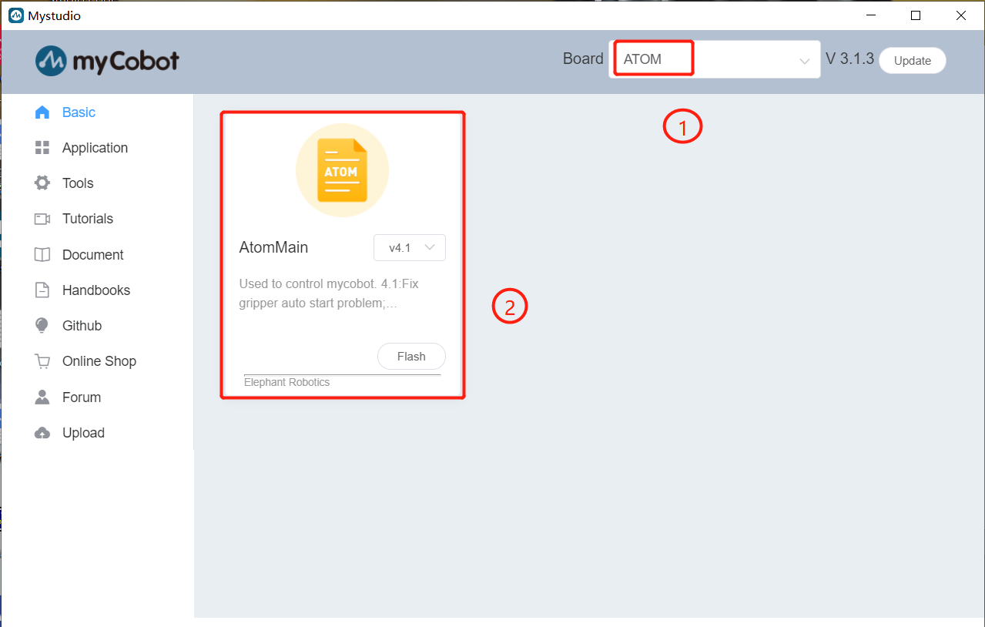

**3.The programming methods for mycobot280-Pi and mycobot320-Pi are the same, and they are explained together.**

1. Mycobot280-Pi and mycobot320-Pi do not need to install any driver.
2. Important point: mycobot280-Pi and mycobot320-Pi do not need to burn basic firmware, only need to burn atom firmware.
3. Mycobot280-Pi and mycobot320-Pi do not need to download mystudio software. After mycobot280-Pi and mycobot320-Pi are connected to the monitor and powered on, the mystudio software built into the system will appear on the desktop.
4. Burn the atom firmware.

Use the USB to typeC cable to connect the USB port on the base of the robotic arm (Raspberry Pi) with the typeC port of the top atom, open the mystudio software on the desktop, select the corresponding device and enter, select the atom firmware atommain4.1 to burn

**4.So far, the firmware burning step has been completed.**

**Note:** Generally speaking, after getting the robot, you need to burn the latest basic firmware and atom firmware, but you also need to choose the corresponding firmware according to your needs. The corresponding firmware requirements have been given in our gitbook document, so I won't go into details here.